Run To The Lost: A call to a national and international evangelical weekend of outreach.
We humbly call upon all pastors, teachers, evangelists, lay-ministers, volunteers, and generally the body of Christ at large, to set aside the 1st-4th of this October 2020, to run to the lost in a collaborative national and international weekend of reaching the lost with the Gospel.
Background:
These are the days of Noah. Imminent judgment through tribulation is about to fall upon a Christ rejecting world. Deception from the enemy is soaring to new heights as Satan is making every attempt to set himself above our Most Hight God.
For the Church, these are the days of Laodicean complacency, and like the prophet Jonah, we are trading our God given mission for material comfort, and the great commission has become the great omission.
Jonah admits: “I know that You are a gracious and merciful God, slow to anger and abundant in lovingkindness, One who relents from doing harm.”
Our fear is that like Jonah, Christians including myself, are falling prey to the endless news cycles and tactics of division from the enemy, and our hearts are becoming cold as we see people committing every lawless deed and sinful act.
Indeed, lawlessness does abound and the love of many is growing colder and colder, and we like Jonah would rather stand back and watch God judge those who carry out these lawless deeds out of a sense of patriotism or righteous indignation than see them saved!
Alas, Jesus said, “You do not know what manner of spirit you are of. For the Son of Man did not come to destroy men’s lives but to save them.”
Can we not help but hear that rebuke from Jesus as if it were for us? It may be, then, that God has allowed things to get out control to this extent, not to judge us, but to wake up His children through discipline as He did Jonah, so that we will return to our first love, to remember how we were once lost and needed a savior, and to remember our purpose of bringing that message, of God’s grace and mercy, the message of the Gospel to a sinful world.
Second Chances:
Jonah said “When my soul fainted within me, I remembered the Lord; And my prayer went up to You, Into Your holy temple.”
It was at this time that Jonah truly began to have awe and reverence for God, and the fear of the Lord was no longer lip service as he earlier represented himself to the sailors.
Is our soul not fainting now, Christian? Are we not vexed by one headline after another of the devastation of a fallen world system? This time of discipline is a time to raise our eyes up to heaven!
Jonah Ran to His Mission
With his newfound respect for Gods overarching redemptive plan, Jonah ran an otherwise lengthy journey in one days’ time.
Now more than ever, with the imminency of Christ soon return, we need to be about our Fathers business and acknowledge our purpose as ambassadors of Christ once again.
Our Mission
We need to respond to Gods calling once again through collectively running to the lost with the gospel of Jesus Christ. The harvest is plentiful, but the workers are few. “Therefore, beseech the Lord of the harvest to send out workers into HIS harvest.”!!! (NASB)
Therefore we humbly call upon all Pastors, Teachers, Evangelists, lay-ministers, church leaders, volunteers, and the whole assembly of the body of Christ in every church to collaborate together and have a national and international first weekend of October for evangelical outreach—the magnitude of which this world has never seen.
At this great time in history, the body of believers has at its disposal a level of technological capability to help join forces across this nation and around the world and bring the Gospel in unity, every part of the body of Christ actively participating in one colossal gospel outreach.

Methods:
We pray earnestly, beseech the Lord of the harvest together, to empty ourselves, to be filled of the Holy Spirit, and to wait upon His guiding our outreach methods and style specific to the needs of our local communities and neighbors. Each fellowship and individual have unique gifts and capabilities to carry out His call, so we leave it up to the Lord how He chooses to lead you in doing so.
Last Thought: Conspicuously absent from the call of the great commission, are the barriers that Jesus’ disciples might have faced in fulfilling this call—Fox’s Book of Martyrs will tell you the fate of those who carried out those duties.
We are no different today. In fact, in these last days, the church should be going over and above their reasonable and obedient service to run to the lost despite the abundant cultural pushback. Our command comes from God, not the government, not the world. We belong to God, and we are not justified of our self, but of God.
May the Lord bless you and keep you, make His face to shine upon you, and be gracious to you. The Lord turn His face towards you and give you peace. Amen.

I owe a debt of gratitude to Dr. Andy Woods, who through his Jonah commentary, the Holy Spirit spoke to me, putting a fire in me to initiate this collaborative effort.

You may disseminate this letter with all permissions granted and make changes according to your needs so long as the call and the date do not change.

Resource for witnessing Below

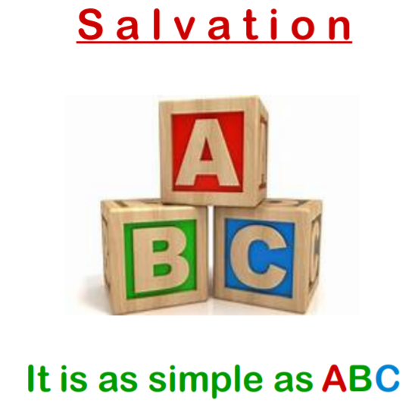

The Gospel of Jesus Christ Today is the day of Salvation: Why would anyone put off the most important decision they could ever make in their lives concerning eternal life? If you die today are you going to heaven? 1 Corinthians 15:1-4 - The apostle Paul tells us what the gospel is: "Moreover, brethren, I declare to you the gospel which I preached to you, which also you received and in which you stand, by which also you are saved, if you hold fast that word which I preached to you—unless you believed in vain. For I delivered to you first of all that which I also received: that Christ died for our sins according to the Scriptures, and that He was buried, and that He rose again the third day according to the Scriptures. Gospel means "good news." Your debt has been paid, the death penalty has been paid, you are free. Here's the Gospel of Jesus Christ: That Christ died for our sins according to the Scriptures, and that He was buried, and that He rose again the third day according to the Scriptures. Jesus brought in a little child as a living object lesson to show who enters the kingdom of heaven. Matthew 18:3 - Jesus said: "Unless you become like this little child you will not enter the kingdom of heaven." This is how to be saved, it is simply child like, as simple as ABC: A - Admit that you are a sinner. This is where that godly sorrow leads to genuine repentance for sinning against a righteous God and there is a change of heart, we change our mind and God changes our hearts and regenerates us from the inside out. Romans 3:10 - As it is written: "There is none righteous, no, not one." Romans 3:23 - For all have sinned and fall short of the glory of God. (We are all born sinners which is why we must be born spiritually in order to enter the Kingdom of Heaven). Romans 6:23 - For the wages of sin is death, but the gift of God is eternal life in Christ Jesus our Lord. The bad news is that the wages of sin is death, in other words our sin means that we have been given a death sentence, we have the death penalty hanging over our heads, that's the bad news. But here's the good news: The good news is that the gift of God is eternal life in Christ Jesus our Lord. Ephesians 2:8-9 - For it is by grace you have been saved, through faith —and this not from yourselves, it is the gift of God— not by works, so that no one can boast. B - Believe in your heart that Jesus Christ died for your sins, was buried, and that God raised Jesus from the dead. This is trusting with all of your heart that Jesus Christ is who he said he was. Romans 10:9-10 - That if you confess with your mouth, "Jesus is Lord," and believe in your heart that God raised Him from the dead, you will be saved. For it is with your heart that you believe and are justified, and it is with your mouth that you confess and are saved. C - Call upon the name of the Lord. Every single person who ever lived since Adam will bend their knee and confess with their mouth that Jesus Christ is Lord, the Lord of lords and the King of kings. Romans 14:11 - For it is written: "As I live, says the Lord, Every knee shall bow to Me, And every tongue shall confess to God." Don't wait until later — do this now. Romans 10:13 - For "whoever calls on the name of the Lord shall be saved." "O God, I am a sinner. I'm sorry for my sin. I want to turn from my sin. I believe Jesus Christ is Your Son; I believe that He died on the cross for my sin and that He was buried and You raised Him to life. I have decided to place my faith in Jesus Christ as my Savior, trusting only in His shed blood as sufficient to save my soul and to take me to heaven. Thank You, Lord Jesus, for saving me. Amen." S a l v a t i o n It is as simple as ABC

